**WAL-MART Stores, Inc. (NYSE: WMT)**

**Sector:** Retail

**Current Percentage of Portfolio:** 7.27%

**Analyst Recommendation:** HOLD

**Analyst:** Daniel Shu

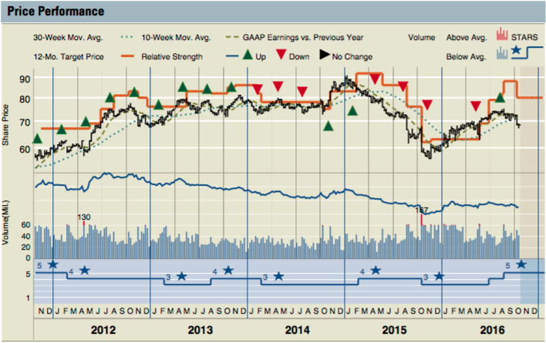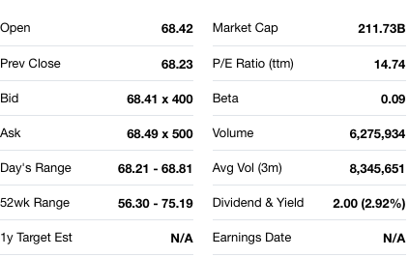

**Business Summary**

Wal-Mart is an American international retail chain that operates as retail and wholesale, consisting of discount department stores and grocery stores. They offer an assortment of products and services from a wide variety at low prices. Wal-Mart commands operations in over 27 countries outside the United States. The three operating segments for the company include Walmart U.S., Walmart International, and Sam’s Club.

**Earnings & Dividends Coverage**

Wal-Mart Stores, Inc. is expected to report earnings on November 17, 2016 for the fiscal quarter ending October 2016. Last quarter’s earnings were reported as $1.07, outperforming the expected EPS of $1.02 by 4.9%. The 2017 first quarter raked in 115.9 billion dollars in total revenue. According to the earnings info graphic released by Walmart, of the total was 73.3 billion dollars in net sales from Walmart U.S., 28.1 billion from Walmart International, and 13.6 billion from Sam’ Club. Moreover, Walmart’s dividend growth is looking strong, as Walmart hit their 43rd consecutive year of annual dividend increases after raising it to $2.00 this past year. The fiscal year 2017 cash dividends will be paid out in four quarterly installments of $0.50 per share. The payment date for the dividends will be executed on January 3rd, 2017. The quarter end EPS estimate is forecasted to be between $0.93 to $0.96.

**Acquirement of Jet.com, Inc.**

On August 6th, 2016 Wal-Mart Stores, Inc. and Jet.com, Inc., the online retail store, announced that they have made a definitive agreement for Wal-Mart to acquire Jet for 3 billion dollars in cash. Additionally, 300 million dollars of Walmart shares will be paid over time. The acquisition was part of an effort for Walmart to compete with the likes of Amazon, the leader of online retailing e-commerce in the nation. Furthermore, the founder of Jet was put in charge of the newly combined company’s entire online operations. This is Wal-Mart’s biggest endeavor to compete with Amazon, which has dominated the e-commerce industry in an equally, if not more, commanding position as Walmart in the brick-and-mortar industry. Wal-Mart has been struggling to keep up in the online retailing business, as their e-commerce share of total sales commands only 2.8% of their total sales, whereas Amazon’s e-commerce controls 74.1% of their total sales. Amazon’s e-commerce sales were nearly $80 billion whereas Walmart’s were approximately $13.5 billion. On the bright note, Jet.com, Inc. is one of the fastest growing e-Commerce companies in the United States. While many praised Walmart for this decision as an effort to overcome Amazon, some analysts were skeptical, claiming while that Jet.com is on pace to hit $1 billion in annual revenues, Amazon is already on pace to exceed $100 billion in annual sales this year. They also dispute that Jet is far from profitable due to their enormous spending on advertising which takes away much of their potential for profits.

**Share Buybacks**

The Board of Walmart approved a $20 billion share repurchase program in October 2015, which the company plans to complete by the end of the fiscal year 2017. Annual EPS is projected to be around $4.34 for 2017, down 4.6% from $4.55 in 2016.

**Analyst Opinion**

As the biggest brick-and-mortar retail company in the world, Walmart prioritizes growth through many methods, including improved in-stock levels, a more aggressive pricing strategy, better customer service and increased customer convenience from growth in e-commerce product offerings. The growth in the e-commerce sector is instrumental to Walmart’s business operations. The online business sales are expected by Capital IQ to increase by 15% the upcoming fiscal year. Not only is it already the largest business in the world based on annual revenues alone of $483 billion but the company also shows great potential in its growth prospect. With over 11,000 locations around the world, Walmart continues to expand and dominate with its “Everyday low prices” slogan.

The company offers great assurance and consistency through its incessant annual dividend growth. After 43 years, the dividends are still growing yearly, and it doesn’t appear as though Walmart is going to break that trend. Overall, most analysts are rating Walmart as a hold or buy and noting that it’s a solid company to have in one’s portfolio due to its consistency and risk averseness. Historically, Walmart’s stock shows to be fairly unwavering over the past several years.

I believe Walmart is a stock that the management team should consider holding due to Walmart’s potential, especially after the acquisition of Jet so we are due to see a change in the performance of the company. Walmart has said that it will invest billions in lowering prices in the upcoming years. As technology grows, Walmart will ascent as well because they focus heavily on incorporating innovative technology to grow their operations, which will make it more ergonomic for customers. Moreover, Jet’s one of the fastest growing online retailers in the country, and the acquirement of the Jet owner to bring his experience and knowledge to the Walmart e-commerce segment should bring a lot of upside to Walmart, especially in their endeavor to eclipse its competitors. Lastly, Walmart is one of the stocks on the market which are evidently more unaffected by market change, so it should be considered a safe bet to put a significant amount of shares into the portfolio.